GIT VERSION CONTROL SYSTEM BY USING AMAZON WEB SERVER

Lab-1-(Creating Ec2 instance)

* Login to aws console
* Create a server with amazon linux

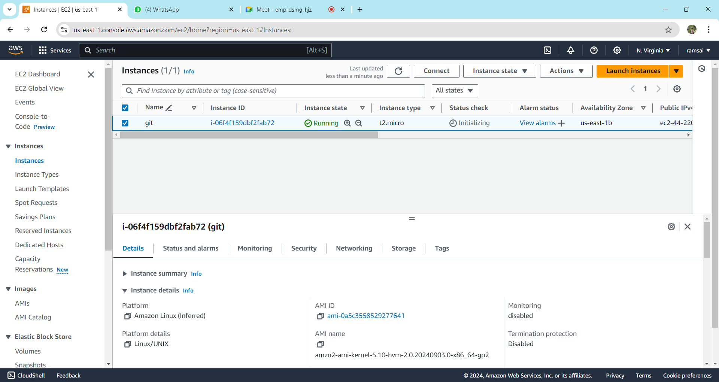

* Connect the server only with putty/gitbash.

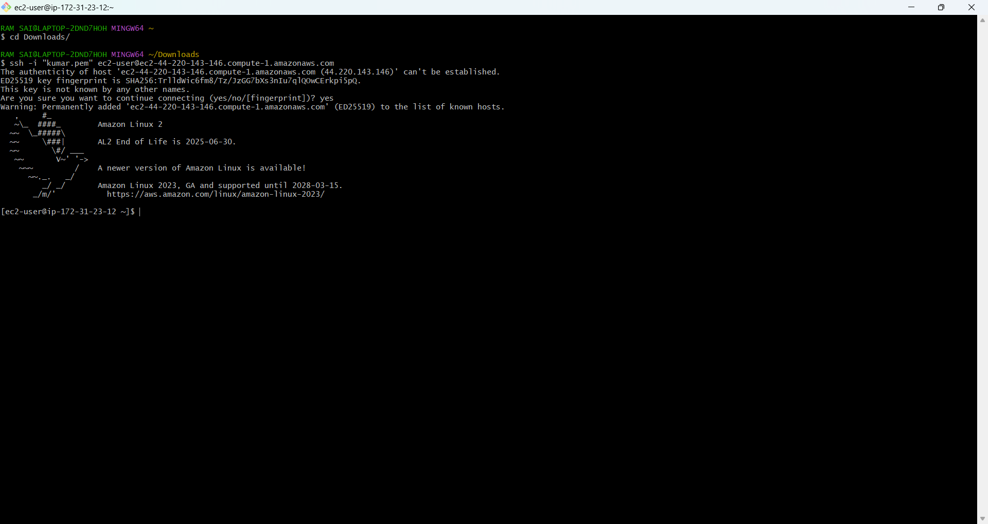

Lab-2(Create Repo in the local machine)

* Create a folder on my local machine

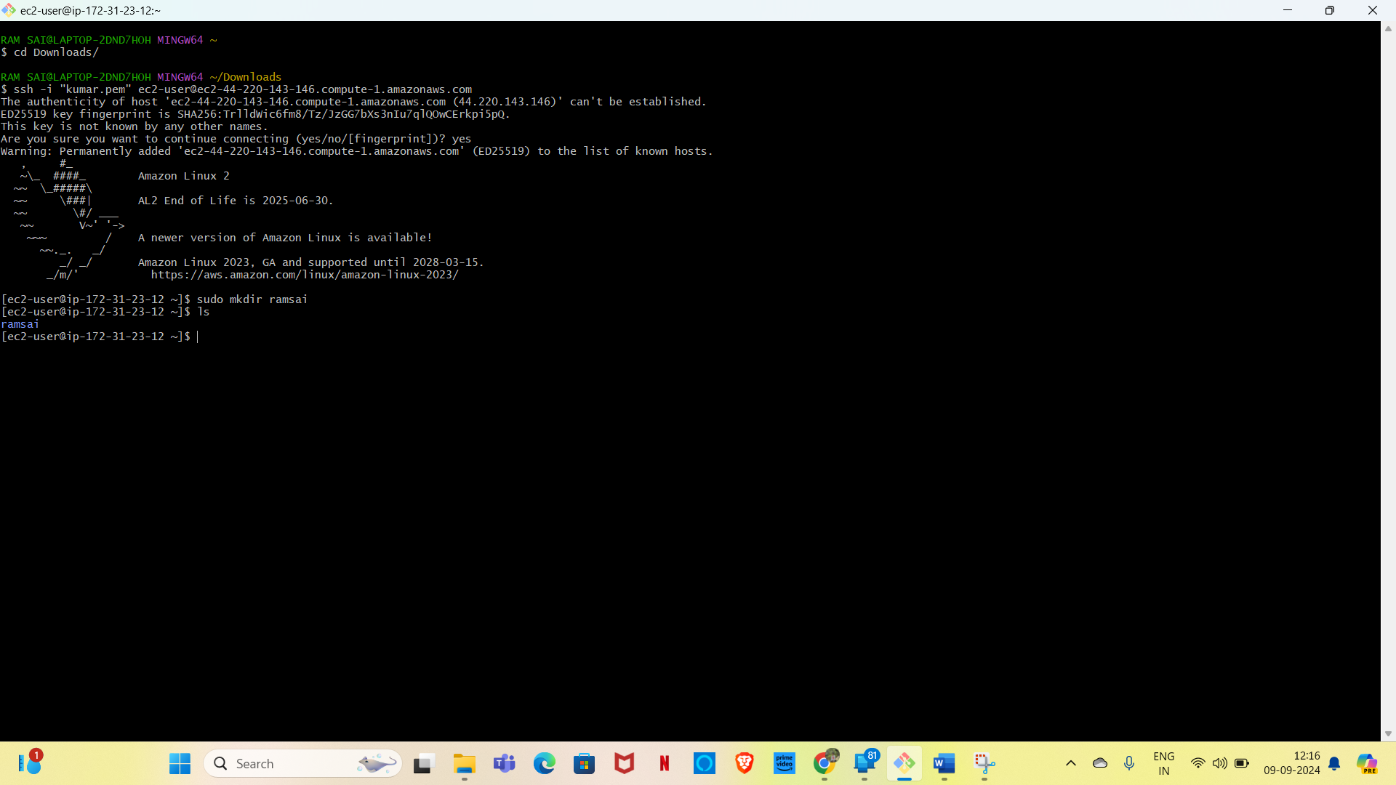

* Initialize this folder using git init command
* a🡪git init <folder name>

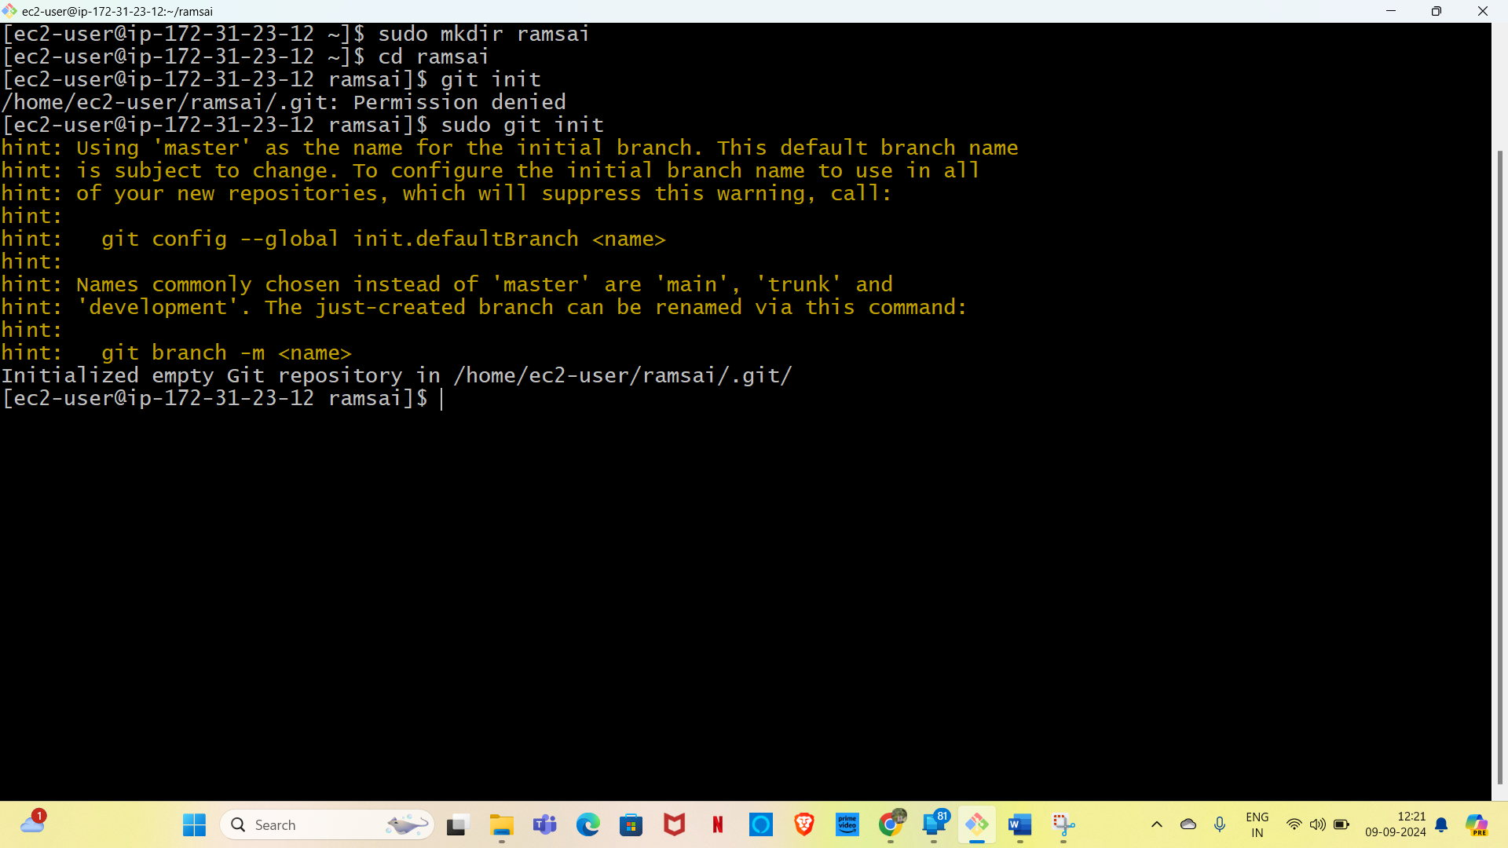

* go inside this folder and run git status command to check the status

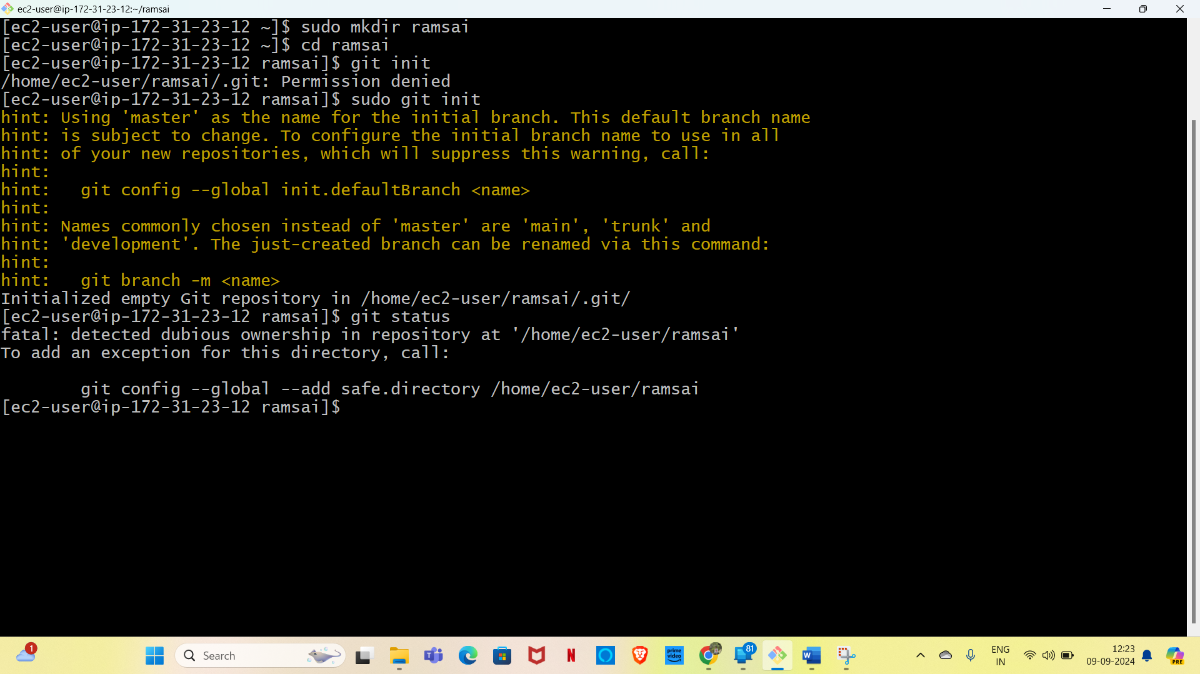

* created some empty files using touch command
* a 🡪 touch test

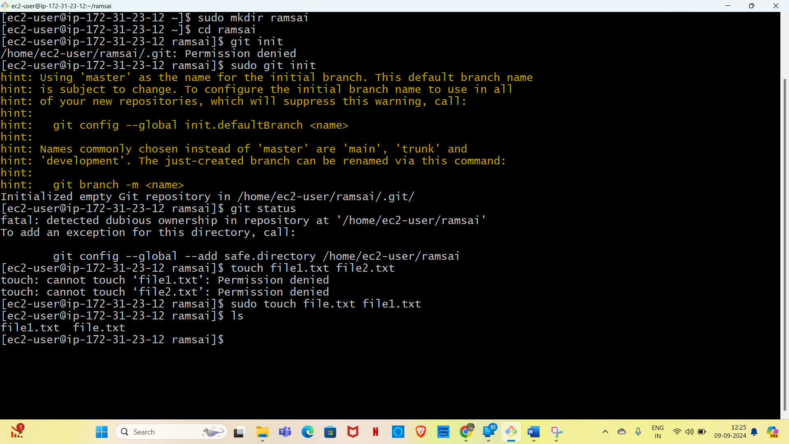

* again, run git status to see the changes you can notice that the file is available but not tracked by git

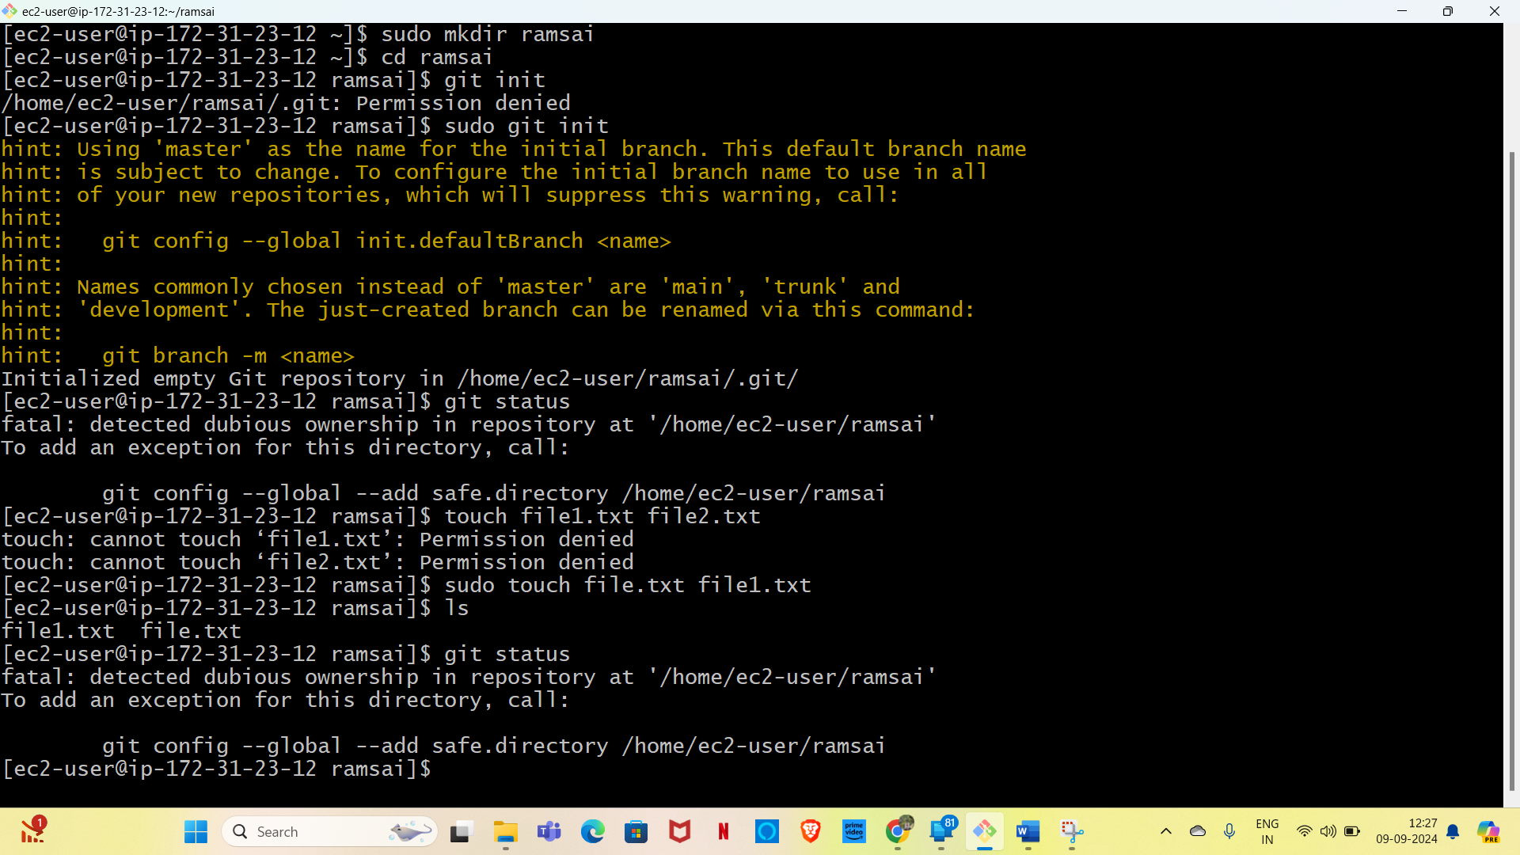

* run git add<filename> to stage this change (git will tracking this file) you may check it using git status once again

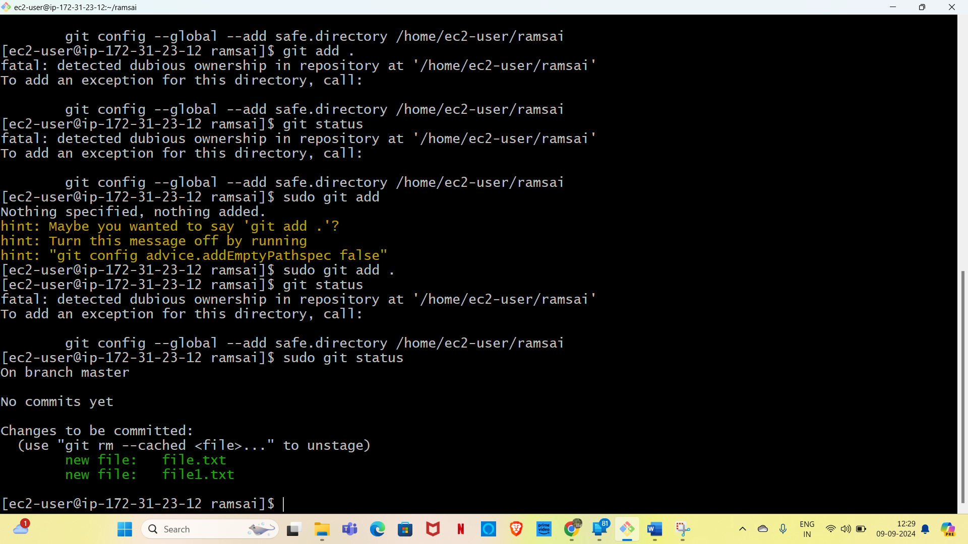

* now commit our changes by running git commit - “added test files”

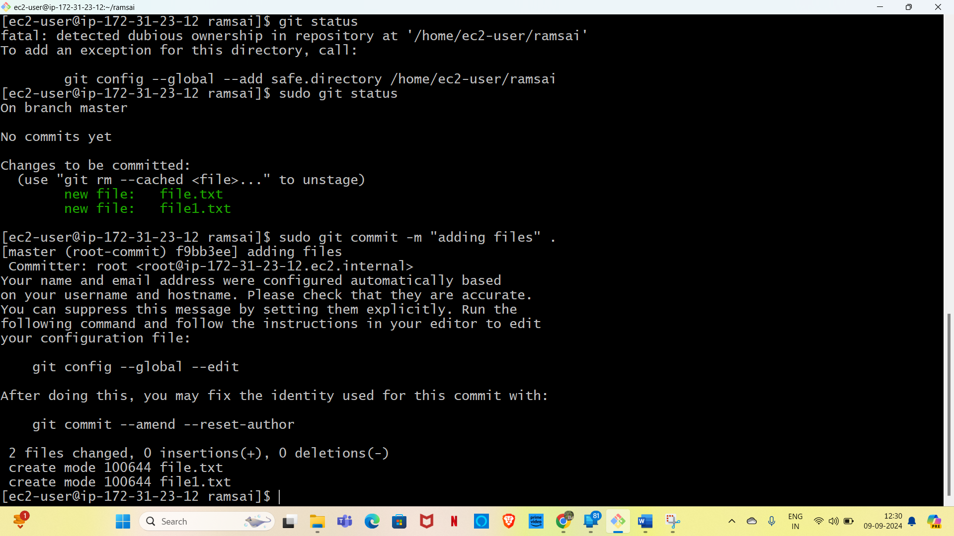

* run git status once again and it will show you that the working tree is clean.

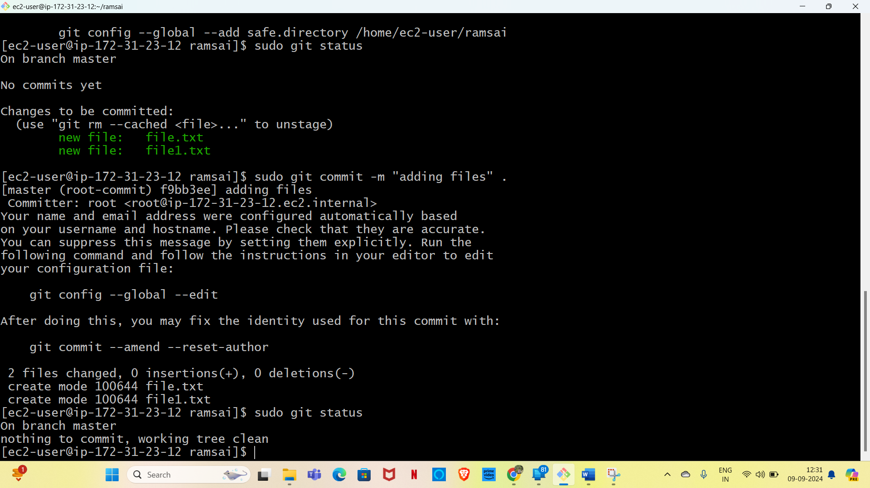

Lab-3-Creating Repo in remote location-github

* In remote location – git hub

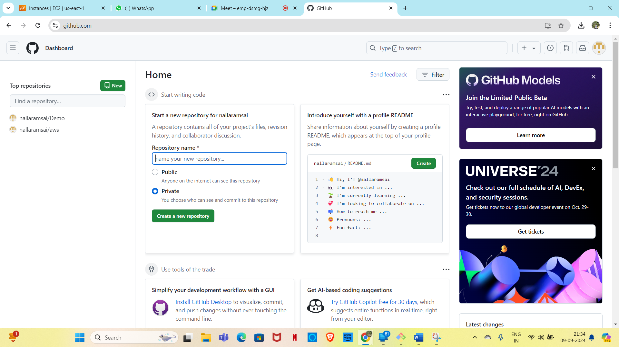

* Create a new repo by clicking on new button
* provide repo name
* select whether it is provide or public repo
* initialilize the repo by adding A README.md file

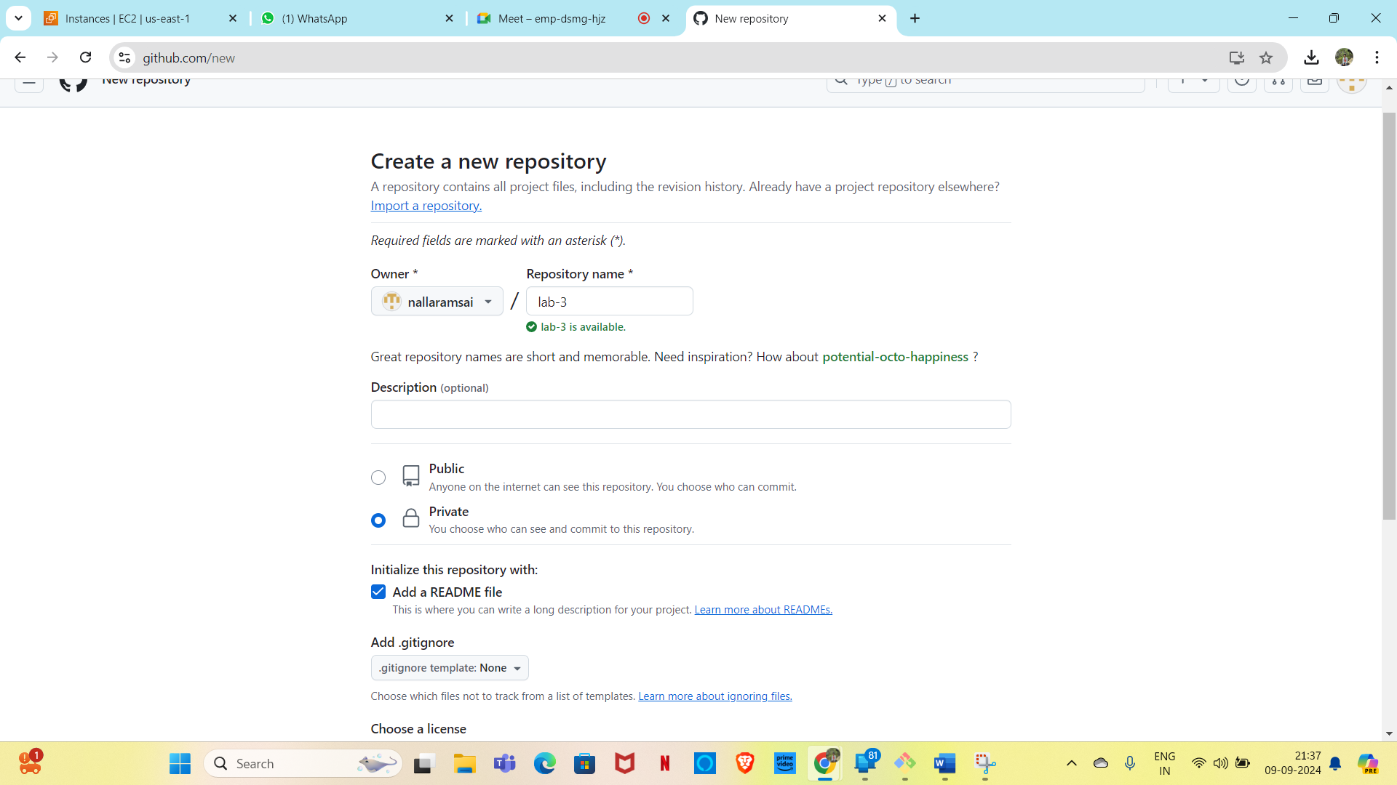

* click on the create repo and done

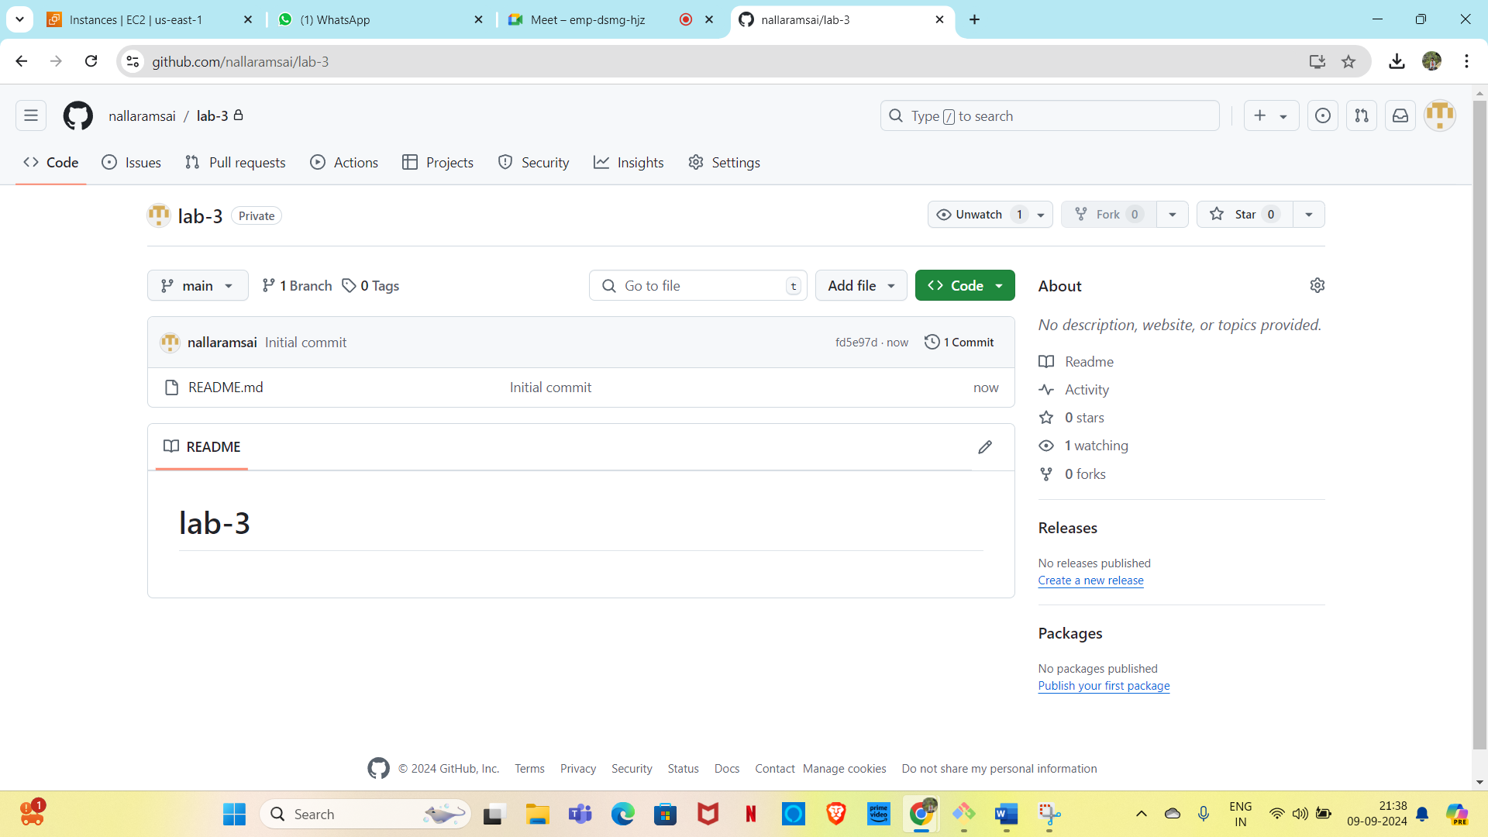

Lab-4-Working with remote repo

* Take the remote repo to your local.
* Machine make the changes

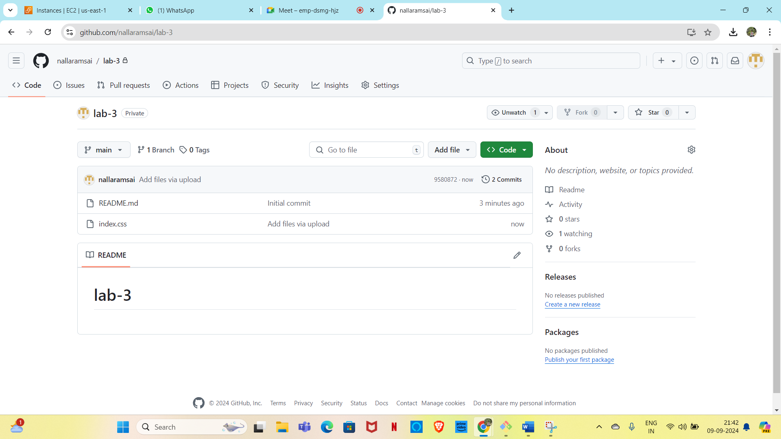

* Pick the clone url of the clone url of the repo from the github repo.
* Go to the local machine and clone this repo using git clone command.
* Git clone <repo url that you will get by clicking on code button in github
* You will be asked a provide username and password
* Here you will get one error for password –based authentication depreciation.

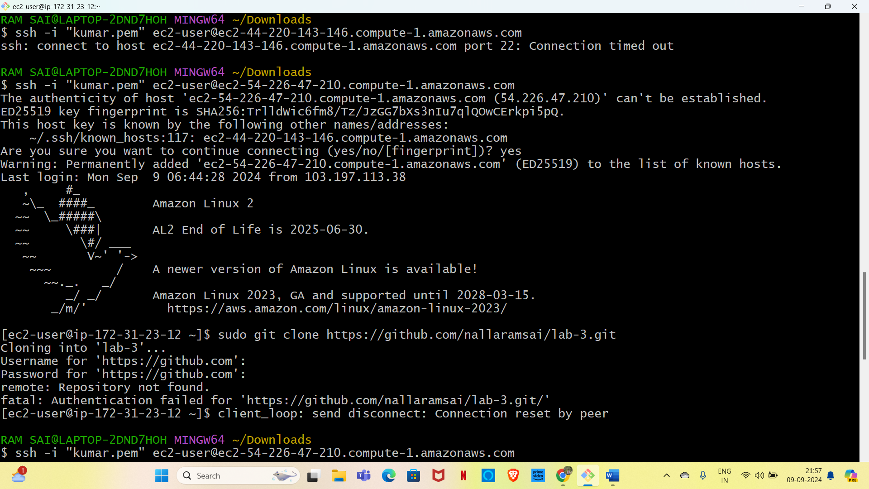

* Clone the repo again in your local machine and this time provide the token in the place of password
* 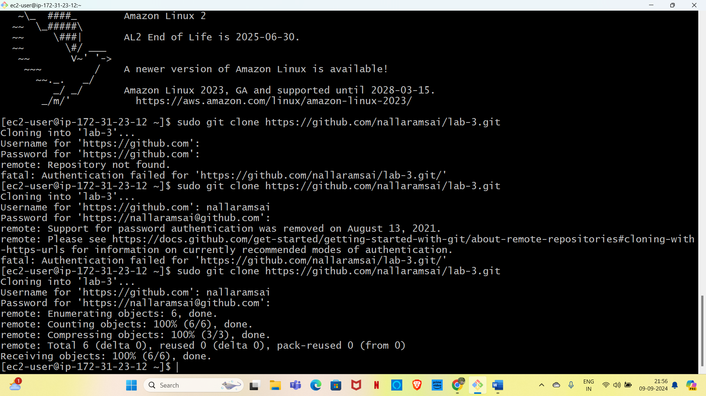

Once cloned go to the repo folder and add some samples files we can us touch command to create empty files

* Touch f1 f2

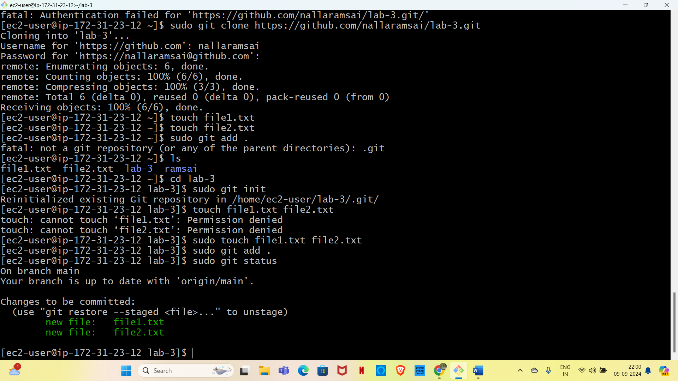

* Commit these changes by running git commit –m <any changes>

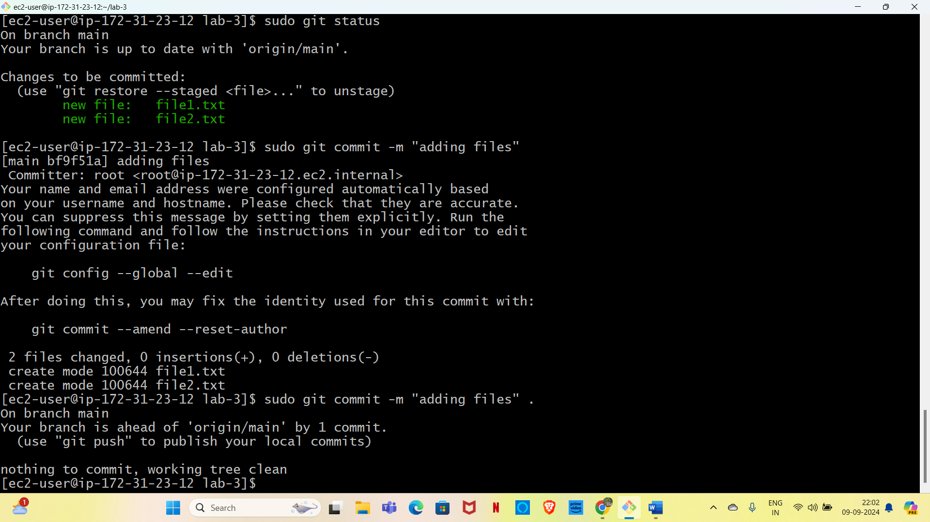

* Git push 🡪it will ask you for username and password provide thr username and PAT in the place of password which we created

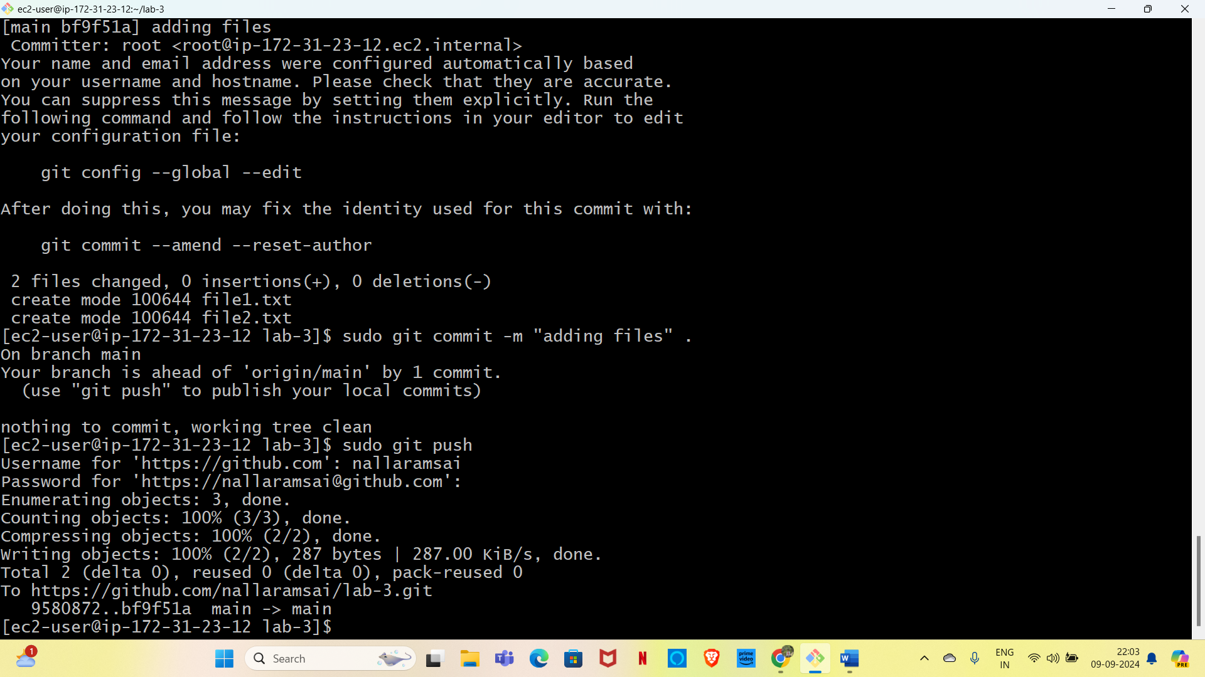

* Go to the remote repo and see you will be able to find your new changes

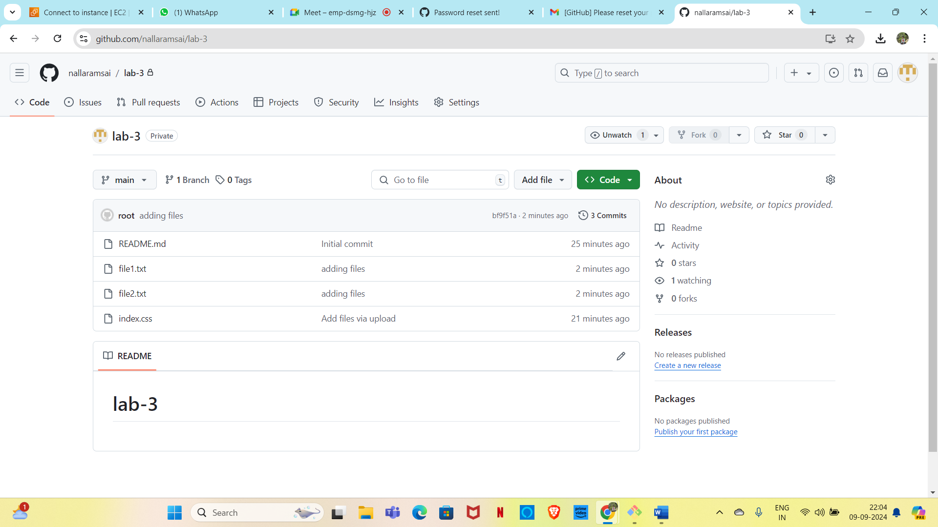

Lab-5 Pushing local

* Create on repo in our local machine and inialize it locally

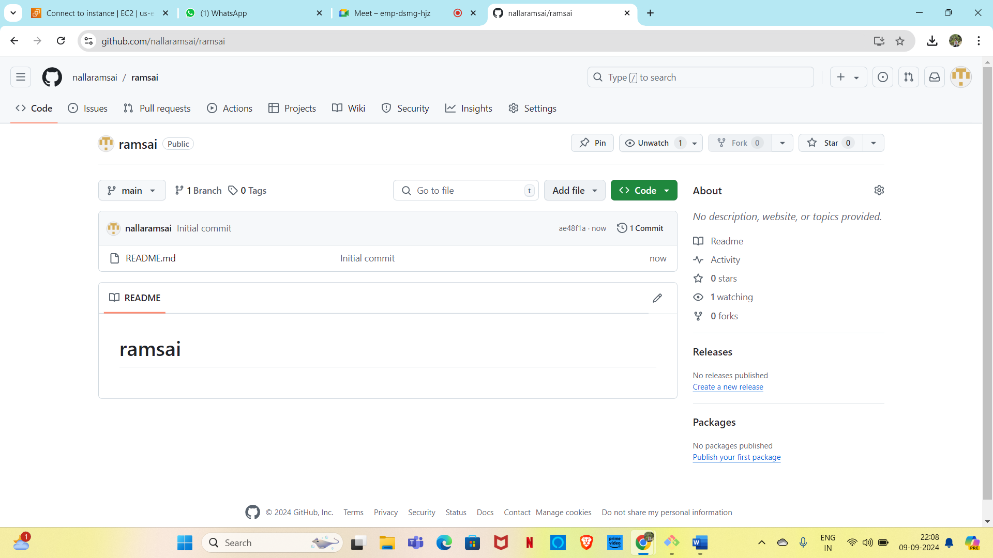

* Come to your local machine and run the following commands from inside your local repo
* Git branch –M(to change the
* Git remote add origin <url>
* GIT PUSH –u origin main

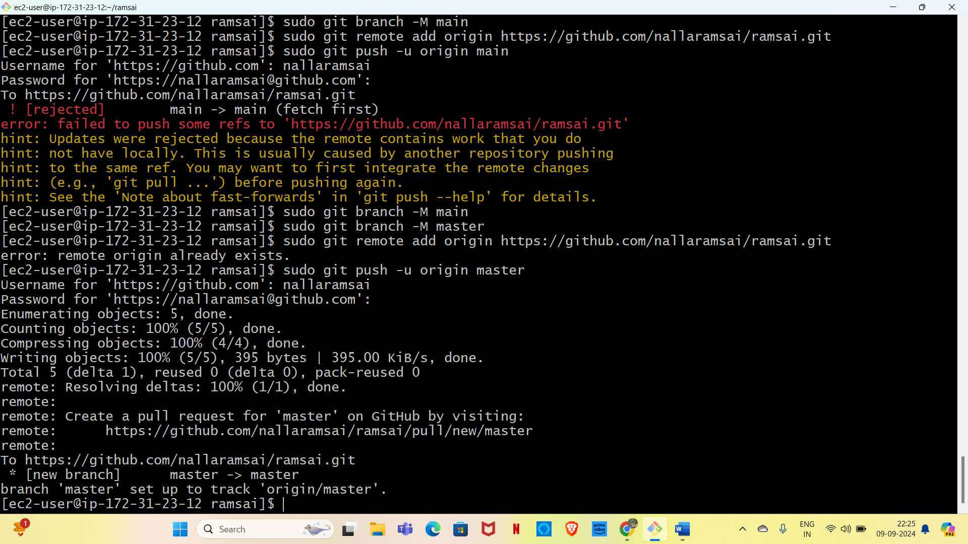

Lab-6- (Creating a new branch from your main branch)

* Go to the repo at the place of main and click on the branch dropdown
* Type the name of your new branch that you want to create and click on the create button
* A new branch will created for u

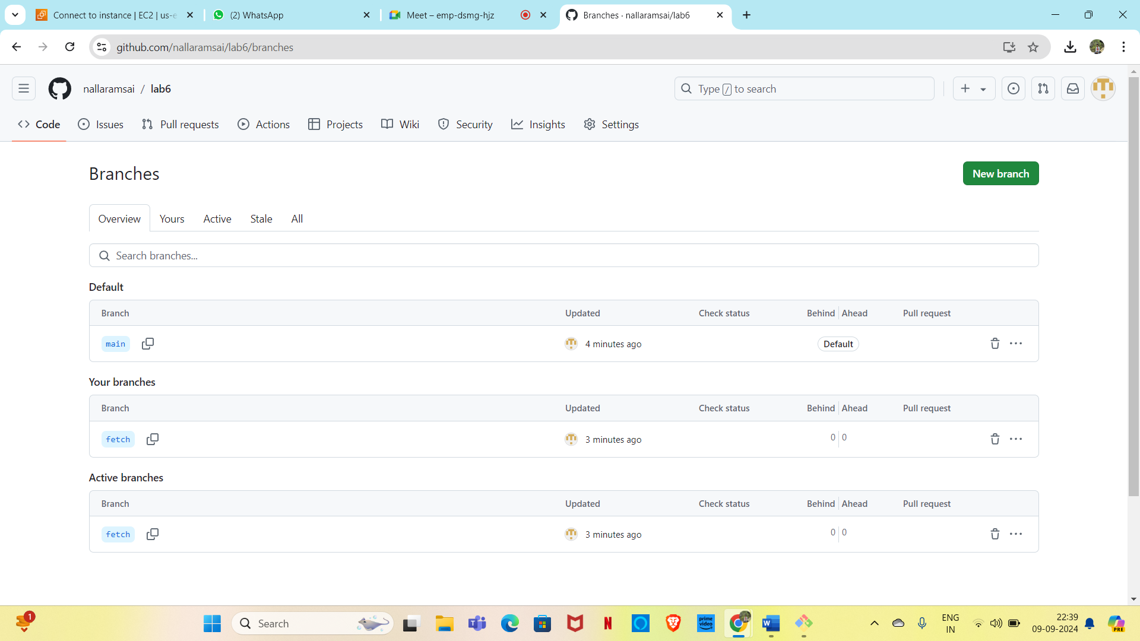

* Make some changes in this branch directly from the console.

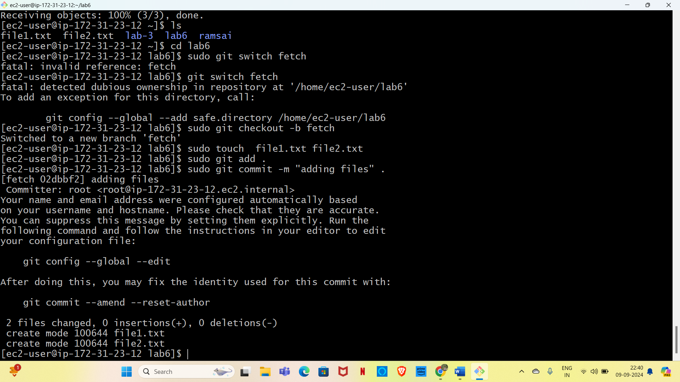

* Here you will see that your changes are only applied to your new branch but not to the main branch

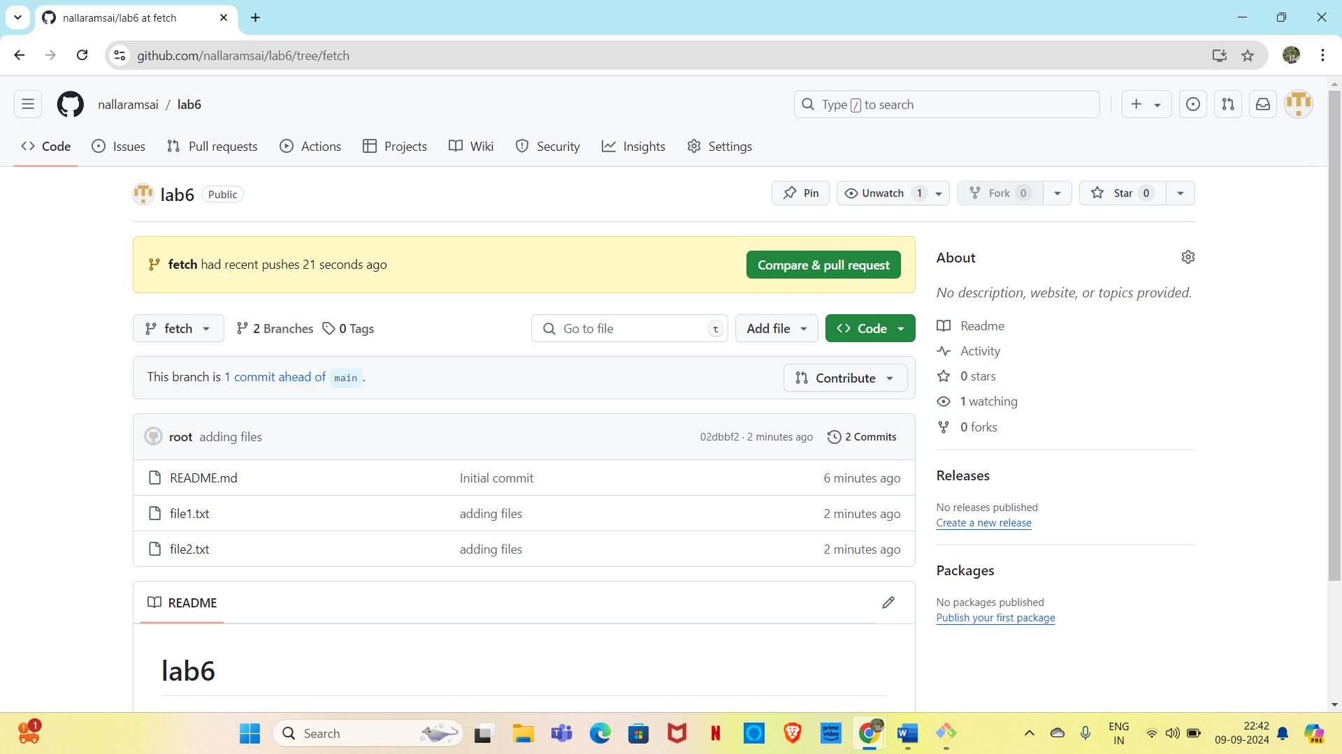

Lab-7-(Pull all the branches in your local machine)

* Go to your local repo machine where you have the copy of your remote branch .

Run the command ”git branch –a” to list down all the branches

* The branch which starts with remote/🡪are the remote branches
* The branch without remotes 🡪they are available on your local copy as well.

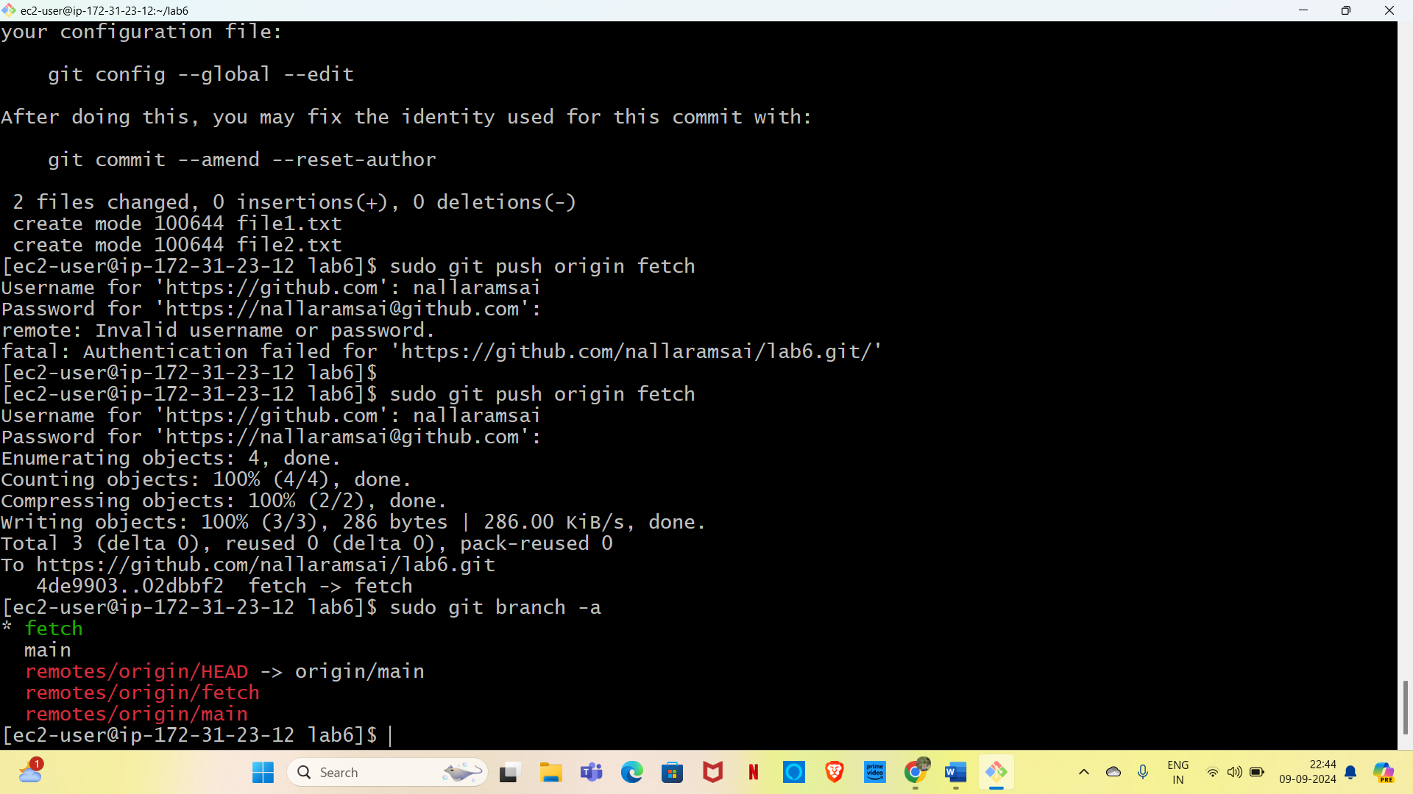

* Checkout to the feature branch or the branch or the branch that you created
* Git checkout <branch name

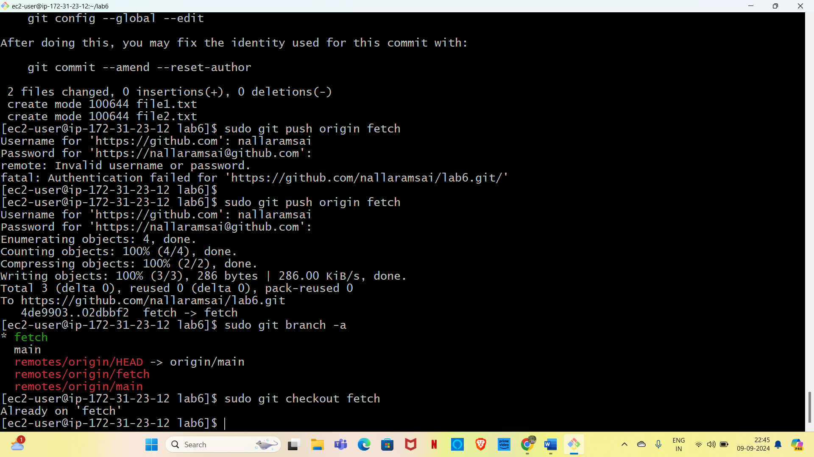

* Make sure that you are on the new branch by running git status or git branch command

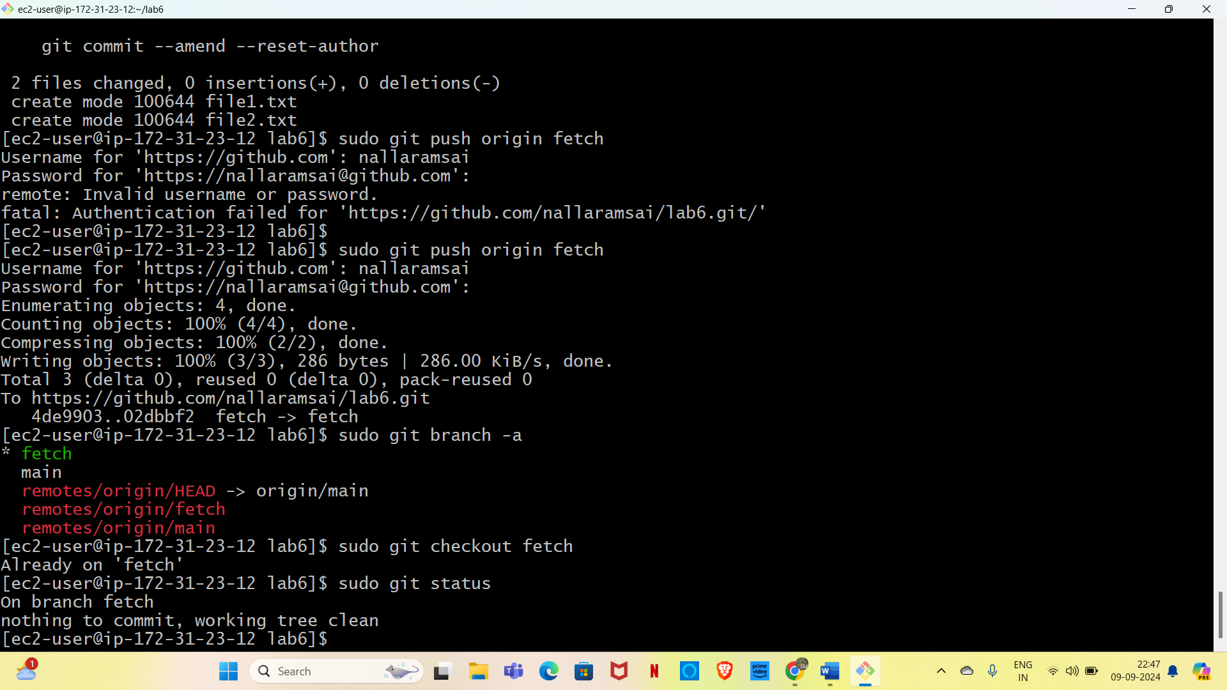

* Make some changes in this branch such as adding the files “touch file3 file 4 “

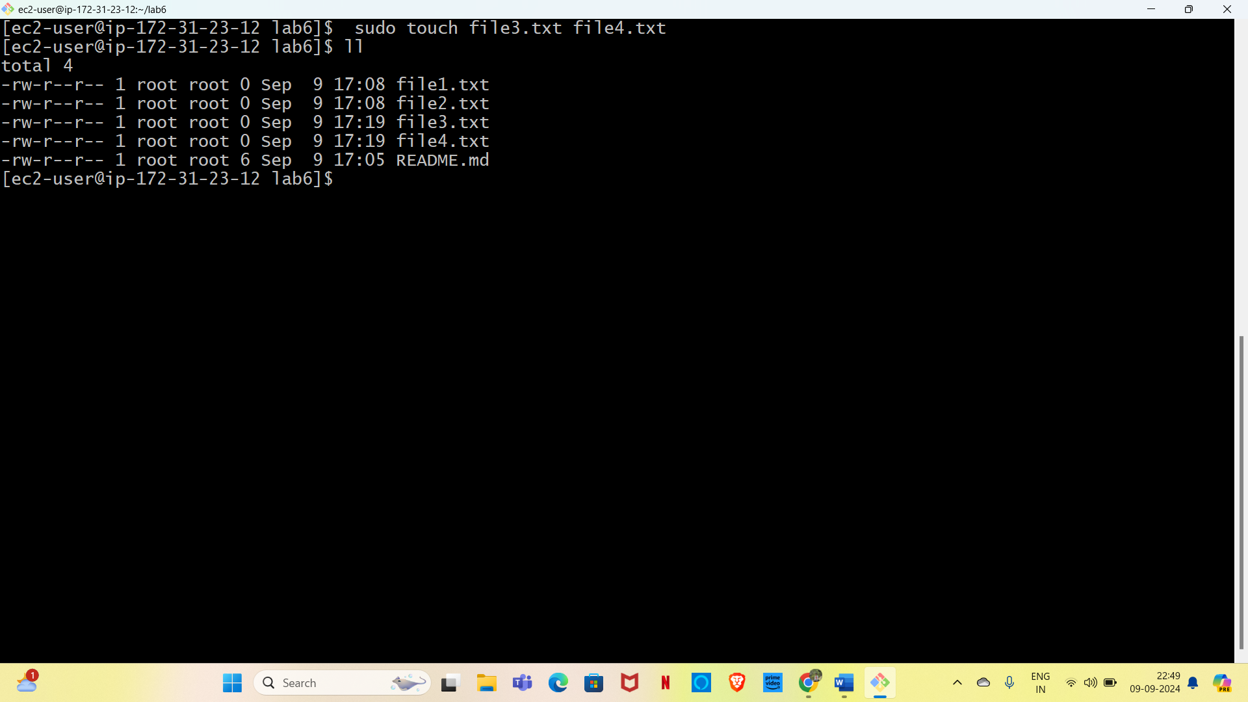

* Here see that the new changes are only available in your feature branch but not in the maun branch

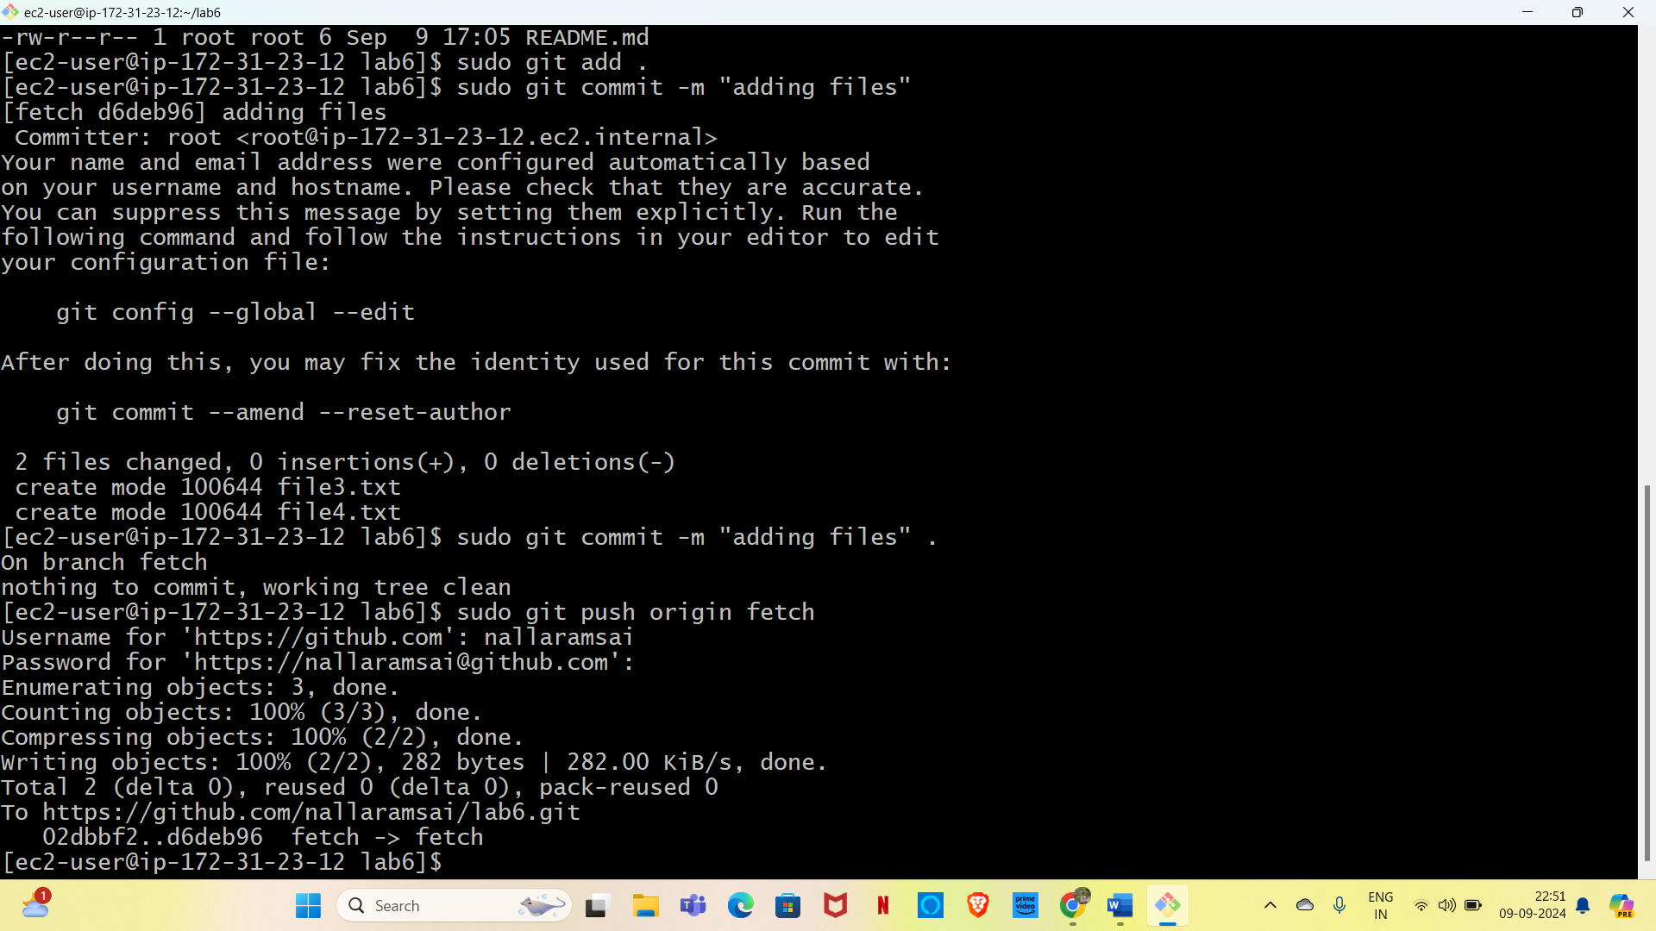

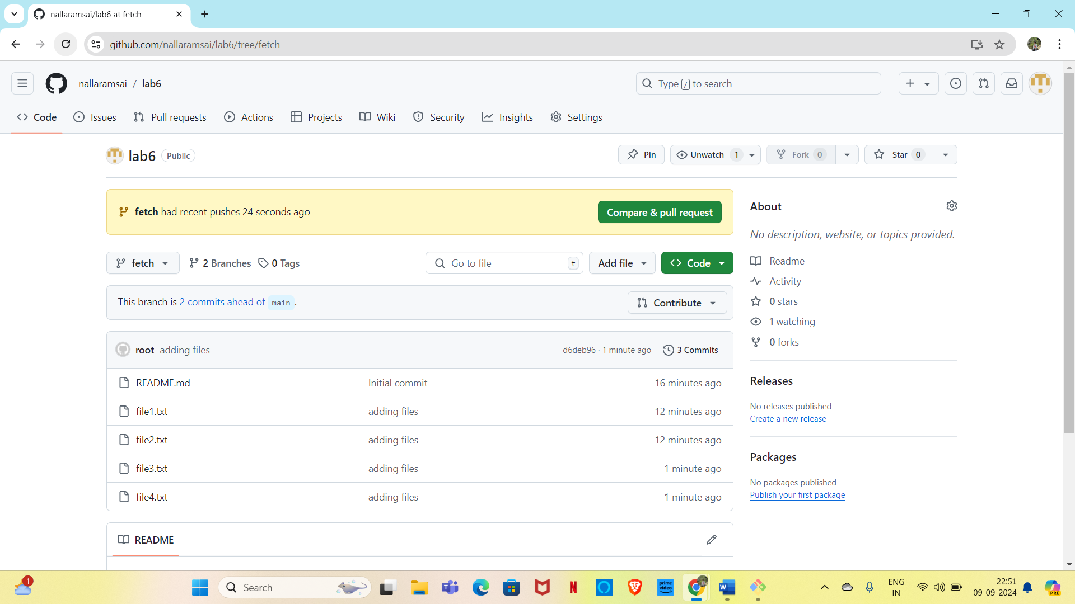

* The main branch didn’t get any affect.

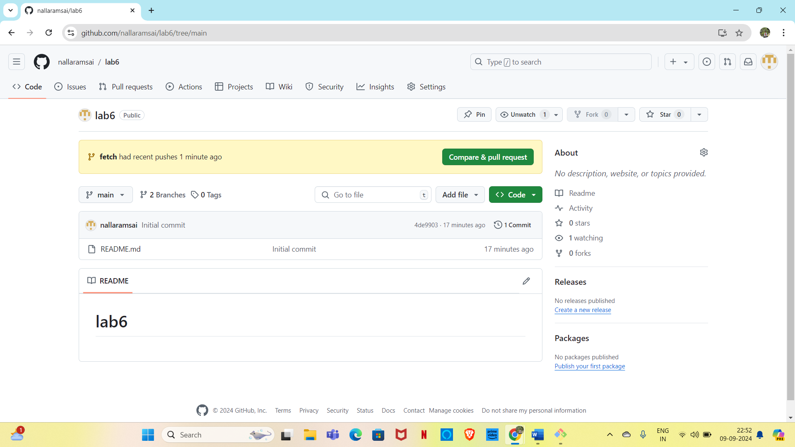

Lab-8- (Merge our feature branch with the main branch.)

* Go to the pull request tab and click on create pull request
* Put your main branch and the feature branch in the request blocks

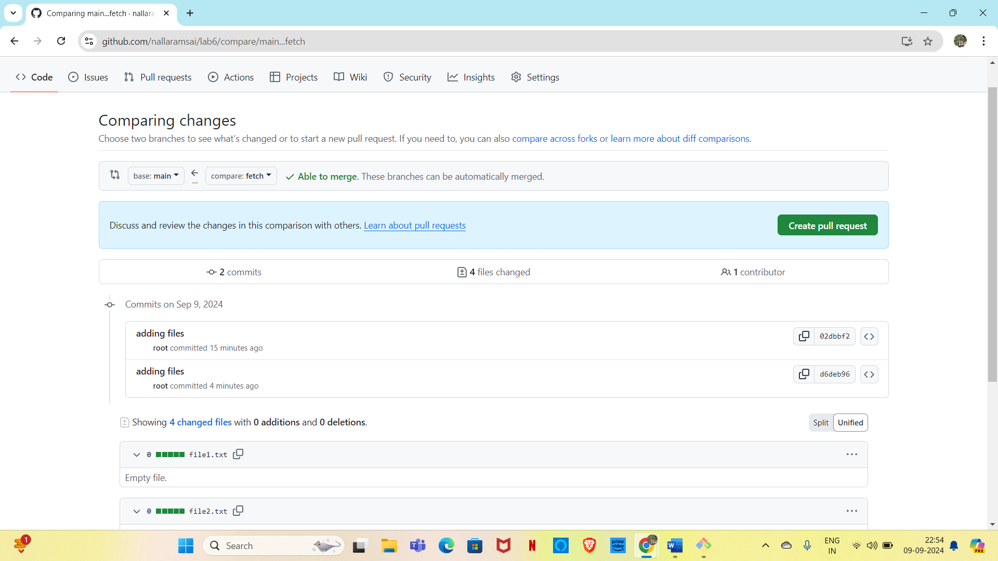

* Click on the create pull request and it will ask for a comment just click again on pull request
* Go to pull request tab once again and click on the pull request available there

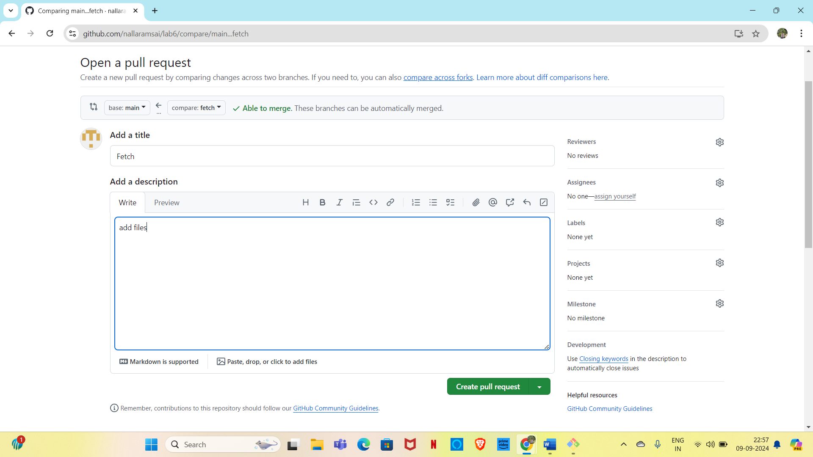

* Click on review changes and then merge

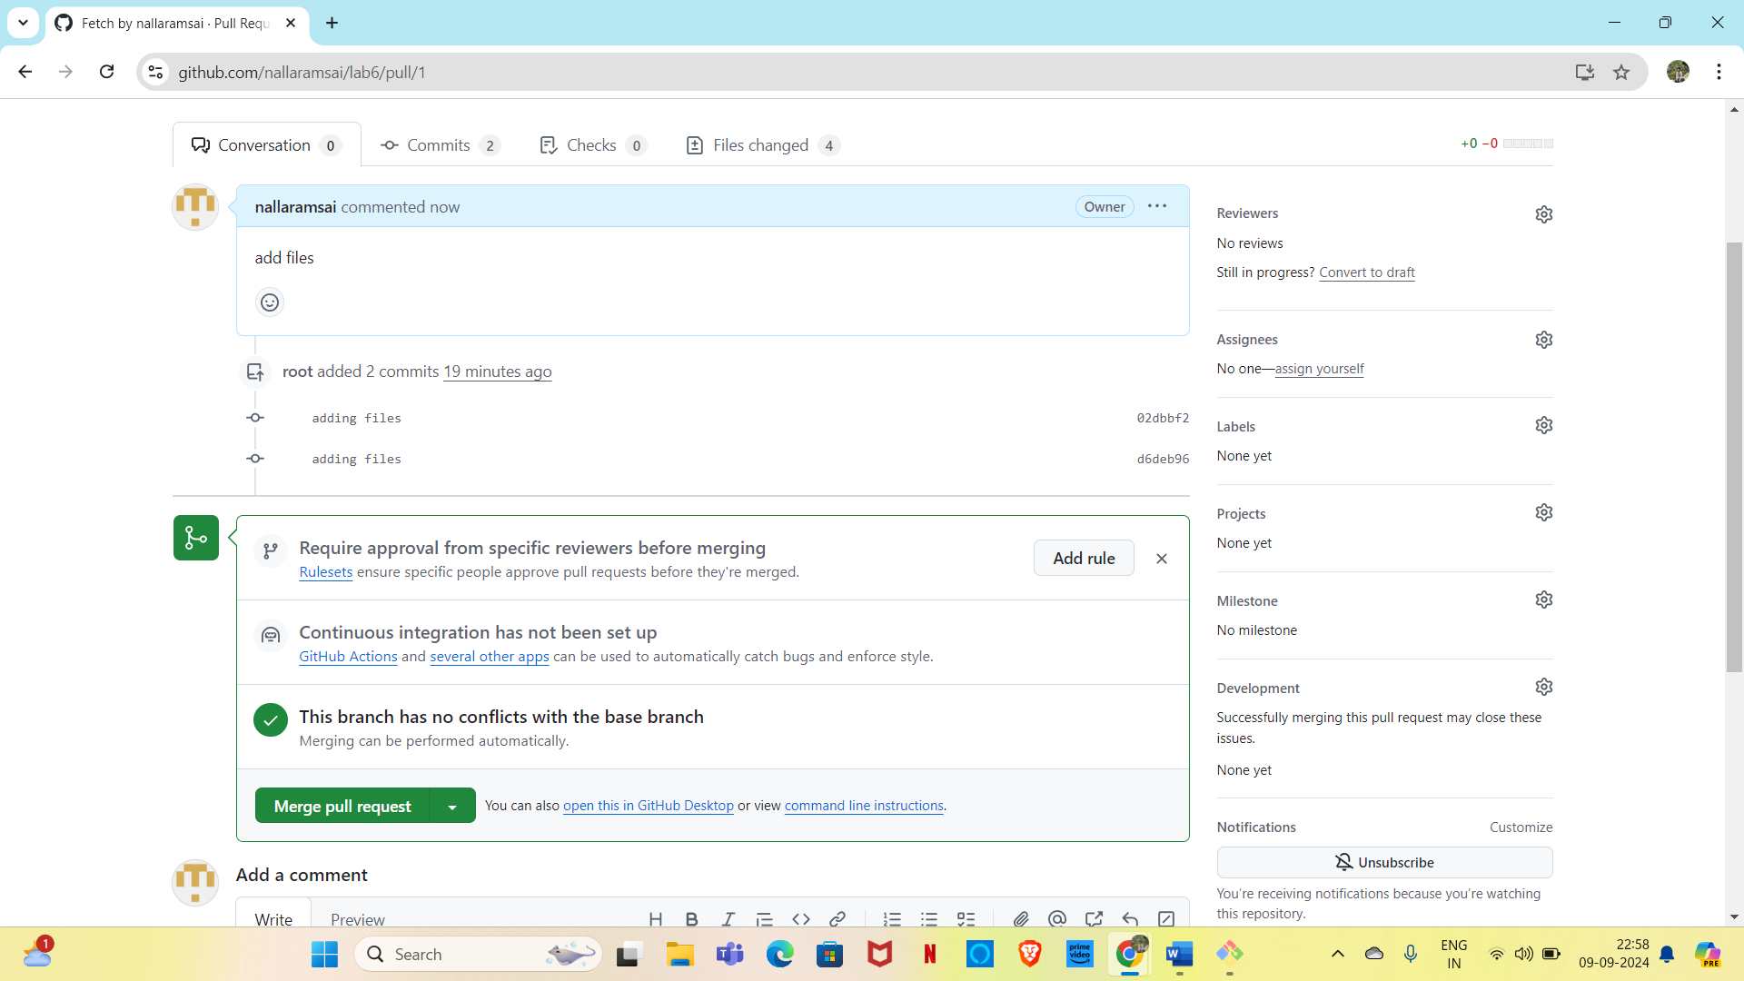

* Once done you can delete this feature branch if required or u can simply ignore it
* Go to your code in main branch and see the changes are now visible here

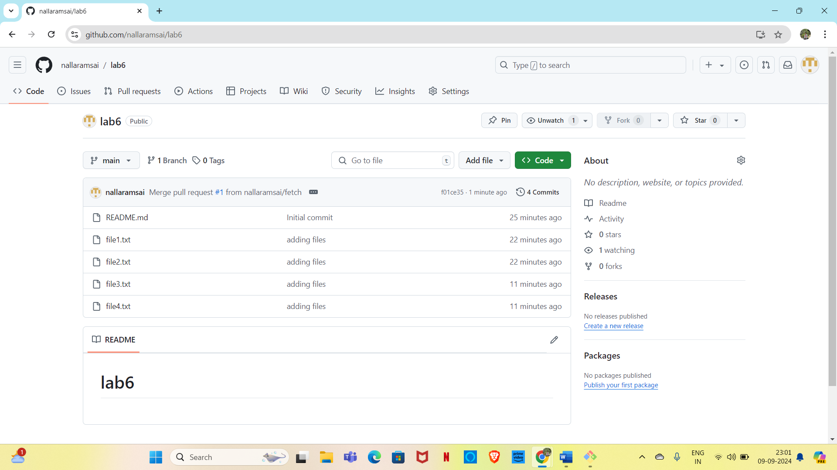

Lab-9-Go to local machine

* Go to your local machine where you have the copy of your remote repo .

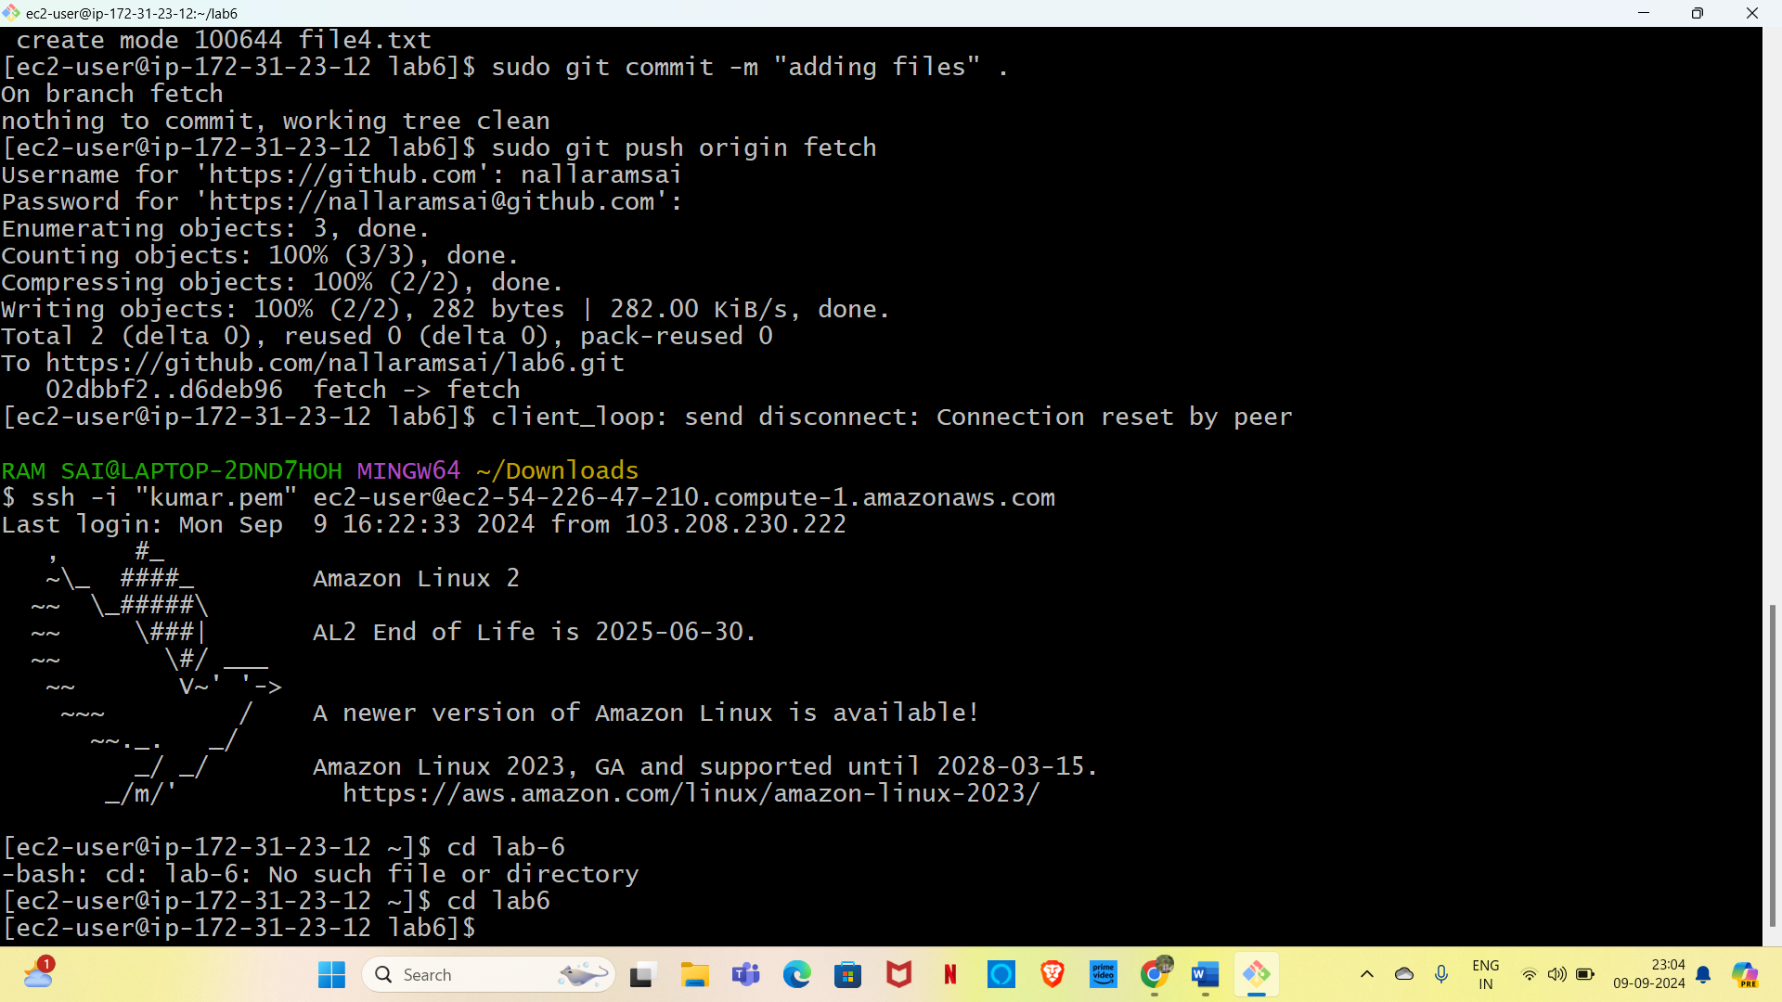

* Checkout to the main branch
* Git checkout<branch name>
* Git pull run the command.
* 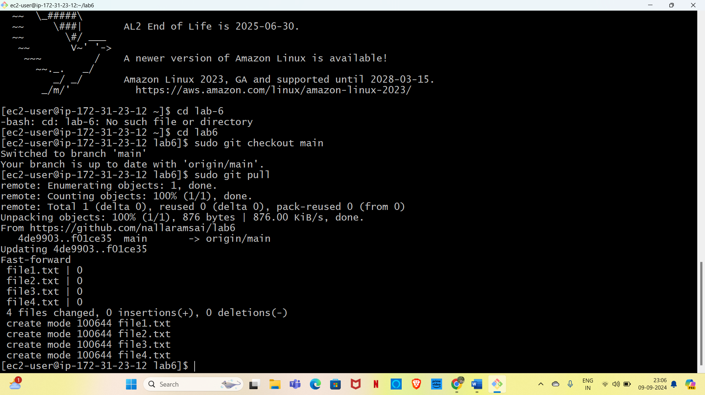
* Here see that the new changes are only available in main branch.

